Building Unreal Engine from Source

Building Unreal Engine from Source
Our development and support teams currently use the latest version of Ubuntu; as a result, we may not be able to provide support for other Linux distributions (including other versions of Ubuntu). Additionally, read about Hardware and Software Specifications, and make sure your system has at least one hundred (100) gigabytes of disk space before performing the following steps.

1.Inside the root directory, run Setup.sh from the terminal to setup the files needed to generate the project files.

2.Now, run GenerateProjectFiles.sh from the terminal to generate your project files.
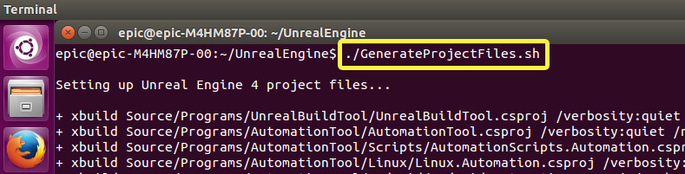
3.To build the project, run make from the terminal.
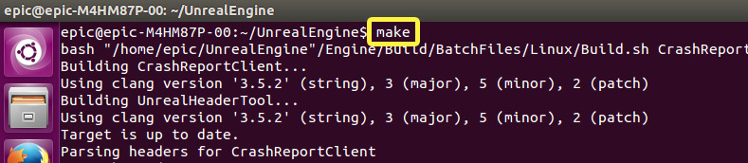
Depending on your system's specifications, it may take anywhere from ten minutes to over an hour to compile the engine. If you want to shorten the time it takes to compile the engine from source, we recommend compiling the source code on a machine that has at least eight (8) gigabytes of RAM, with a multi-core processor having at least eight (8) cores (including hyperthreading).

Running the Editor

1.Navigate to the editor's binary path by entering cd Engine/Binaries/Linux/ into the terminal.
2.Run UnrealEditor to launch the editor.
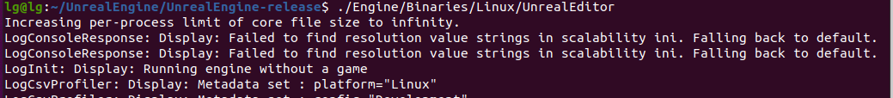
3. Congratulations! You've compiled and launched the engine from source.

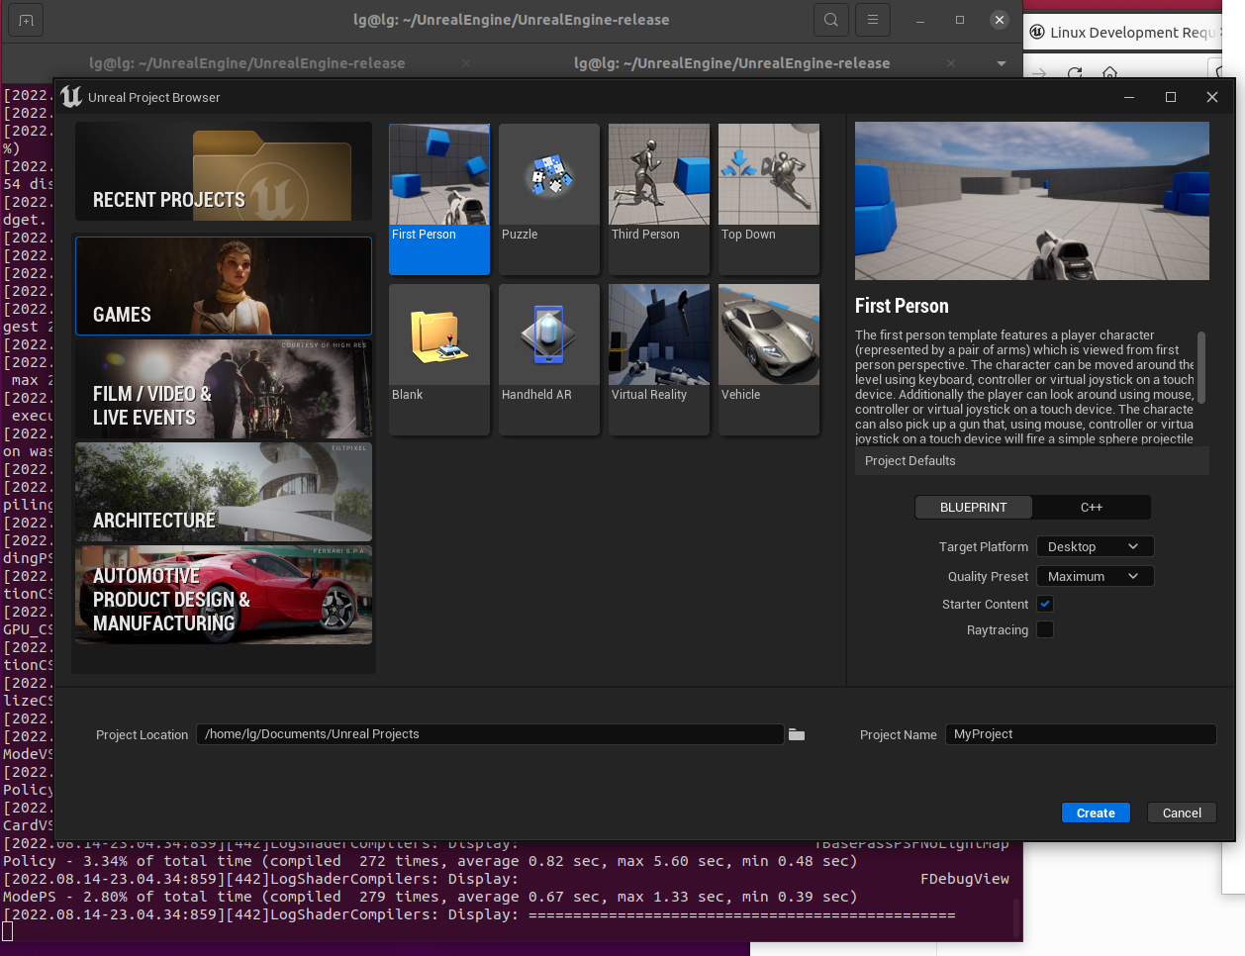

Getting Started with Unreal Engine

Learn how to use Unreal Engine by referring to the Understanding the Basics documentation!
If you're looking to quickly get started with UE4, refer to the following tutorials:
- Programming Quick Start
- Level Designer Quick Start

NOTE
UE4's in-editor help features are a great way to get your questions answered.

LINKS:

1.https://docs.unrealengine.com/5.0/en-US/installing-unreal-engine/
2.https://docs.unrealengine.com/5.0/en-US/downloading-unreal-engine-source-code/
3.https://docs.unrealengine.com/5.0/en-US/building-unreal-engine-from-source/

